MySQL INNER JOIN

Here, you will learn how to use the MySQL INNER JOIN clause to select data from multiple tables based on join conditions.

## **Introduction to MySQL INNER JOIN clause**

The INNER JOIN matches each row in one table with every row in other tables and allows you to query rows that contain columns from both tables.

The INNER JOIN is an optional clause of the SELECT statement. It appears immediately after the FROM clause. Here is the syntax of the INNER JOIN clause:

SELECT

select_list

FROM t1

INNER JOIN t2 ON join_condition1

INNER JOIN t3 ON join_condition2;

In this syntax:

* First, specify the main table that appears in the FROM clause (t1).
* Second, specify the table that will be joined with the main table, which appears in the INNER JOIN clause (t2, t3,…).
* Third, specify a join condition after the ON keyword of the INNER JOIN clause. The join condition specifies the rule for matching rows between the main table and the table appeared in the INNER JOIN clause.

Assuming that you want to join two tables t1 and t2.

The following statement illustrates how to join two tables t1 and t2 using the INNER JOIN clause:

SELECT

select_list

FROM

t1

INNER JOIN t2 ON join_condition;

The INNER JOIN clause compares each row in the t1 table with every row in the t2 table based on the join condition.

If rows from both tables cause the join condition to evaluate to TRUE, the INNER JOIN creates a new row whose columns contain all columns of rows from the tables and includes this new row in the result set. Otherwise, the INNER JOIN just ignores the rows.

In case no row between tables causes the join condition to evaluate to TRUE, the INNER JOIN returns an empty result set. This logic is also applied when you join more than 2 tables.

The following Venn diagram illustrates how the INNER JOIN clause works:

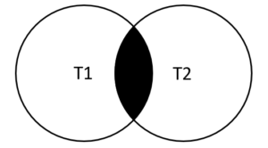

## **MySQL INNER JOIN examples**

Let’s look at the products and productlines tables in the sample database.

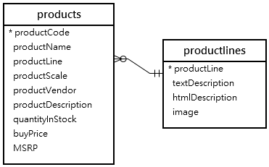

In this diagram, the table products has the column productLine that references the column  productline of the table productlines . The column productLine in the table products is called the foreign key column.

Typically, you join tables that have foreign key relationships like the  productlines and products tables.

Suppose you want to get:

* The productCode and productName from the products table.
* The textDescription of product lines from the productlines table.

To do this, you need to select data from both tables by matching rows based on values in the productline column using the INNER JOIN clause as follows:

SELECT

productCode,

productName,

textDescription

FROM

products t1

INNER JOIN productlines t2

ON t1.productline = t2.productline;

### **MySQL INNER JOIN - Products Data Example**

Because the joined columns of both tables have the same name  productline, you can use the USING syntax:

SELECT

productCode,

productName,

textDescription

FROM

products

INNER JOIN productlines USING (productline);

The query returns the same result set. However, the USING syntax is much shorter and cleaner.

### **MySQL INNER JOIN with GROUP BY clause example**

See the following orders and orderdetails tables:

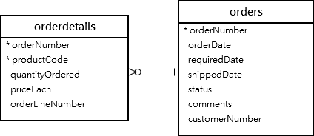

This query returns order number, order status, and total sales from the orders and orderdetails tables using the INNER JOIN clause with the GROUP BYclause:

SELECT

t1.orderNumber,

t1.status,

SUM(quantityOrdered * priceEach) total

FROM

orders t1

INNER JOIN orderdetails t2

ON t1.orderNumber = t2.orderNumber

GROUP BY orderNumber;

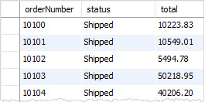

Similarly, the following query uses the INNER JOIN with the USING syntax:

SELECT

orderNumber,

status,

SUM(quantityOrdered * priceEach) total

FROM

orders

INNER JOIN orderdetails USING (orderNumber)

GROUP BY orderNumber;

### **MySQL INNER JOIN – join three tables example**

See the following products, orders and orderdetails tables:

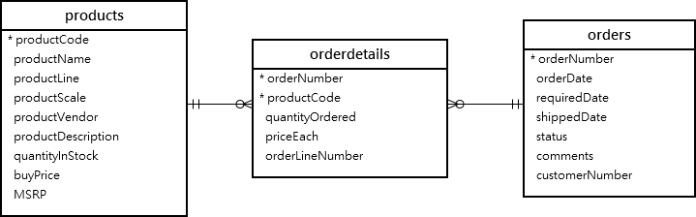

This query uses two INNER JOIN clauses to join three tables: orders, orderdetails, and products:

SELECT

orderNumber,

orderDate,

orderLineNumber,

productName,

quantityOrdered,

priceEach

FROM

orders

INNER JOIN

orderdetails USING (orderNumber)

INNER JOIN

products USING (productCode)

ORDER BY

orderNumber,

orderLineNumber;

This picture shows the partial output:

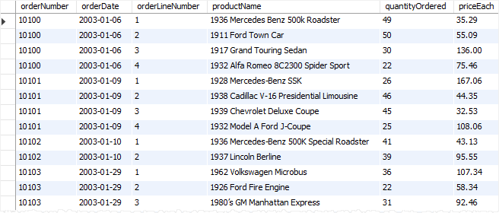

### **MySQL INNER JOIN – join four tables example**

See the following orders, orderdetails, customers and products tables:

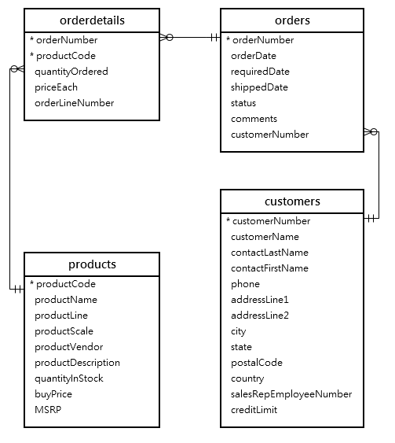

This example uses three INNER JOIN clauses to query data from the four tables above:

SELECT

orderNumber,

orderDate,

customerName,

orderLineNumber,

productName,

quantityOrdered,

priceEach

FROM

orders

INNER JOIN orderdetails

USING (orderNumber)

INNER JOIN products

USING (productCode)

INNER JOIN customers

USING (customerNumber)

ORDER BY

orderNumber,

orderLineNumber;

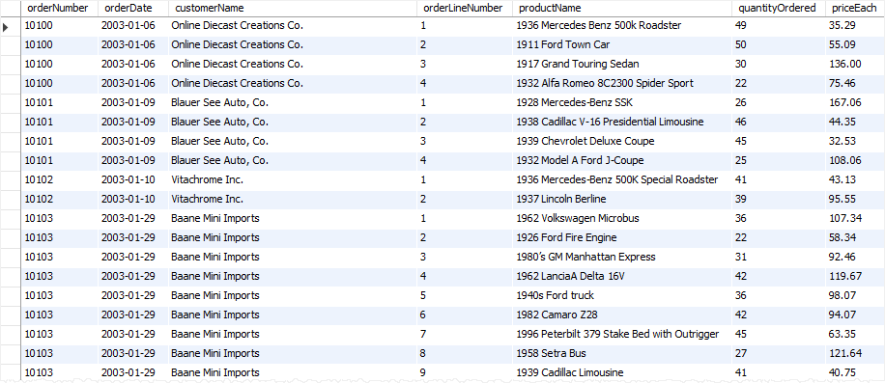

## **MySQL INNER JOIN using other operators**

So far, you have seen that the join condition used the equal operator (=) for matching rows.

In addition to the equal operator (=), you can use other operators such as greater than ( >), less than ( <), and not-equal ( <>) operator to form the join condition.

The following query uses a less-than ( <) join to find the sales price of the product whose code is S10_1678 that is less than the manufacturer’s suggested retail price (MSRP) for that product.

SELECT

orderNumber,

productName,

msrp,

priceEach

FROM

products p

INNER JOIN orderdetails o

ON p.productcode = o.productcode

AND p.msrp > o.priceEach

WHERE

p.productcode = 'S10_1678';

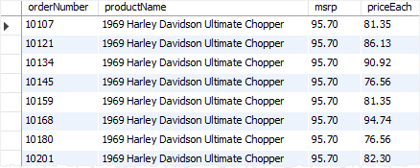

Here, you have learned how to use the MySQL INNER JOIN to query data from multiple tables.